

* Introduction –

Cortex is an open source time series database and monitoring system for applications and micro services. Based on Prometheus, Cortex adds horizontal scaling and virtually indefinite data retention.

**Cortex** tries to solve a common problem frequently encountered by SOCs, CSIRTs and security researchers in the course of threat intelligence, digital forensics and incident response: how to **analyse observables** they have collected.

* Project Summary -

|  |  |
| --- | --- |
|  |  |
| * WEbsite | https://cortexmetrics.io/ |
| * Organization/foundation name | The organization name for Cortex in the open-source community is **"cortexlabs"** |
| * License | **GNU Affero General Public License v3.0** |
| * open / propietry | Open |
| * Source Path(if open source) |  |
| * Brief Description | Cortex is an open source software that provides a scalable and reliable platform for observability and monitoring. With its modular design, Cortex can easily integrate with other monitoring tools and supports various data sources. Its high-performance indexing and querying capabilities allow for efficient storage and retrieval of metrics, logs, and traces. Cortex is a popular choice for managing large-scale distributed systems and cloud-native architectures. |

* **Project Details**
* Key Features :-

some key features of Cortex in open source are:

* Scalability: Cortex can be deployed on a cluster of machines, making it easy to scale horizontally to meet increasing demands.
* Easy to use: Cortex provides a simple API that can be used by developers to deploy models, and it can be easily integrated into existing applications.
* Multi-cloud: Cortex can be deployed on various cloud platforms such as AWS, GCP, and Azure, making it a flexible option for organizations.
* Cost-effective: Cortex uses Kubernetes to manage resources, which can help organizations save money by optimizing resource usage.
* High-performance: Cortex uses a containerized architecture, which provides high-performance and enables developers to run models efficiently.
* Open source: Cortex is an open-source project, which means it is free to use and developers can contribute to the development of the platform.
* Compatibility: Cortex supports various machine learning frameworks such as TensorFlow, PyTorch, and scikit-learn, making it a versatile platform for deploying models.
* Architecture :-

Cortex, an open source, horizontally scalable, multi-tenant Prometheus-as-a-service becomes a CNCF Sandbox project

The following diagram shows its architecture:

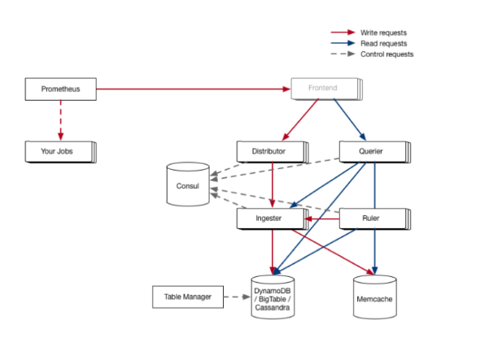

1.**Scraping samples**: First, a Prometheus instance scraps all of the users’ services and then forwards them to a Cortex deployment. It does this using the remote_write API, which was added to Prometheus to support Cortex and other integrations.

2. **Distributor distributes the samples**: The instance then sends all these samples to distributor, which is a stateless service that consults the ring to figure out which ingesters should ingest the sample. The ingesters are arranged using a consistent hash ring, keyed on the fingerprint of the time series, and stored in a consistent data store, such as Consul.

3.**Ingesters make chunks of samples**: Ingesters continuously receive a stream of samples and group them together in chunks. These chunks are then stored in a backend database, such as DynamoDB, BigTable, or Cassandra. Ingesters facilitate this chunking process so that Cortex isn’t constantly writing to its backend database.

* Current Usage :-

Here are some organizations or products that use the Cortex open-source project:

* AWS - Amazon Web Services has integrated Cortex in its cloud platform to enhance its machine learning and deep learning capabilities.

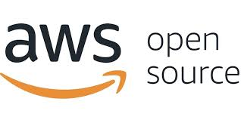

* Uber - Uber uses Cortex for its artificial intelligence-based optimization algorithms to improve its services.



* Facebook - Facebook uses Cortex to develop its machine learning models to enhance user experience and optimize its ad targeting capabilities.



* Spotify - Spotify has integrated Cortex in its recommendation engine to provide personalized music recommendations to its users.



* PayPal - PayPal uses Cortex to enhance its fraud detection algorithms and improve its security measures.



* GitLab - GitLab has integrated Cortex in its platform to enable users to automate their machine learning workflows.



* Nvidia - Nvidia uses Cortex for its machine learning and deep learning projects to optimize its graphics processors.



* Open AI – Open AI uses Cortex to develop its artificial intelligence models for various applications, including language processing and robotics.



* Technical Details:-

Cortex is an open source project that aims to provide a platform for building scalable and real-time analytics applications. The project has been designed to handle large amounts of data and provide real-time insights into that data.

* Scalability:

Cortex is built on top of Apache Kafka and Apache Spark, which are known for their ability to handle large amounts of data in real-time. Cortex uses a distributed architecture, which allows it to scale horizontally by adding more nodes to the cluster. This means that Cortex can handle large amounts of data and scale to meet the needs of growing applications.

* Performance:

Cortex has been designed with performance in mind. It uses in-memory processing to provide real-time insights into data. The project also uses distributed caching, which reduces the latency of accessing data. Cortex also supports multi-threaded processing, which allows it to take advantage of multi-core processors and improve performance.

* Other Technical Information:

Cortex is written in Scala and runs on the Java Virtual Machine (JVM). It supports multiple data sources, including Kafka, Hadoop Distributed File System (HDFS), and Amazon S3. Cortex also supports various data formats, including JSON, Avro, and Parquet.

* Project comparison :
* Cortex vs Prometheus:

Prometheus is another popular open-source monitoring system used for collecting and querying time series data. While Cortex and Prometheus share similarities, such as the ability to query and analyze data in real-time, Cortex has a few advantages. For instance, Cortex offers horizontal scalability, which means it can handle large volumes of data with ease. It also offers better performance, as it can process millions of metrics per second. Additionally, Cortex supports multiple data stores, making it more flexible than Prometheus.

* Cortex vs Thanos:

Thanos is another popular open-source monitoring system that offers similar functionalities to Cortex. However, Thanos differs from Cortex in that it provides more extensive features for data retention and query federation across multiple data centers. While Cortex focuses on scalability and performance, Thanos offers more advanced features for long-term data retention and analysis. Thanos also supports a broader range of data stores than Cortex, making it more flexible in terms of integration with different data sources.

* Cortex vs InfluxDB:

InfluxDB is an open-source time-series database that is often used for monitoring and analyzing large volumes of data. While Cortex and InfluxDB share some similarities, such as real-time data processing and analysis, they differ in several ways.

* Reference / Acknowledgements :-

However, here are some references and acknowledgements for different open source projects that use the term "cortex".

* Information about it on the official website: <https://cortexmetrics.io/>
* information about Cortex-M on the ARM website: <https://developer.arm.com/ip-products/processors/cortex-m>
* Information about Cortex-X on the ARM website:

<https://developer.arm.com/ip-products/processors/cortex-x>